April 13, 2025

Dear Friends and Faithful Supporters of Tabs for Wheelchairs,

Once again, it’s the time of year to recognize and celebrate the tremendous positive difference each and every one of you has made through your continued dedication and support of the Tabs for Wheelchairs program! Thanks to your loyal donations, as of this June, 69 specialized wheelchairs will have been given to young people in our province because of your faithful and continuous efforts.

Just in the past 10 years, Tabs for Wheelchairs has grown from 91 schools collecting tabs to 185 and from 98 companies/groups to 313. This is absolutely amazing! A huge thanks goes out to all of you who keep spreading the word and to CTV who has been with us almost every year at our presentations and is most definitely a part of why we have had such widespread success!
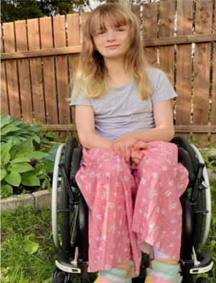

This year, LAILA will be presented with her
CITY 2 PLUS TRAVEL BUGGY POWER CHAIR
on Monday, June 16 at her very own school,
ÉCOLE GEORGE MCDOWELL.

The presentation will be held at 1:00 p.m.
in their school gymnasium.

The school is located in South St. Vital at 366 Paddington Rd. This is the first year ever that the wheelchair presentation is being held at a different location and we’re very excited to be taking Tabs for Wheelchairs on the road!!!

Late last year, we realized our original date for the assembly would not work due to Laila and her classmates being away on a three-day celebratory graduation camping trip. Unfortunately, the Holy Cross gym wasn’t available for the alternative date that would work for Laila. However, when École George McDowell was approached to host the assembly, they were very pleased to do so and to celebrate this special day with Laila, her family, friends, classmates and everyone present.

Our next year’s recipient is DELAINEY, who hails from Steinbach, Manitoba. She is a Grade six student at Stonybrook Middle School. We are very pleased that she is from the Southeastern part of the province as we have over 150 companies, schools and organizations that save tabs with us from this area. I would like to take this opportunity to recognize that the tremendous participation and support the Tabs for Wheelchairs program has received from Southeastern Manitoba is due to the tireless dedication of one of our most faithful supporters, Bob Barrow. He has been with us for a number of years and his efforts have greatly expanded our community. Thank you, Bob!

Thanks, as well, to all those who have made monetary donations over the years! We are very grateful for your generosity! If anyone would like to make a donation, please address your cheque to Holy Cross School and don’t forget to write in the bottom left of the cheque, “Tabs for Wheelchairs”. Income Tax receipts will be given for donations over $20. Please mail your envelope to Gwen Buccini, c/o of Holy Cross School, 300 Dubuc St. Winnipeg MB R2H 1E4.

Please don’t forget to read what is in the body of this email. It will inform you as to where you can deliver your tabs. Make sure everything is delivered no later than Friday, May 30^{th-}. This will make sure that your tabs will be a part of the wall of tabs displayed at the assembly. Places that you can drop off your cans and any kind of metal are also listed in the body of this email.

Please let me know if you are considering attending the presentation as we need to plan seating arrangements.

In closing, we wish to thank you once again for your time, energy and enthusiasm for the program and for helping to make Tabs for Wheelchairs the successful organization it is today! It has been a privilege working with you and meeting so many wonderful and caring people!

Gwen Buccini Mrs. Catherine Walker
Tabs for Wheelchairs Coordinator Principal

